**Figma design:**

[**https://www.figma.com/file/ModJFx5UV0L4tZY8Qhhhai/DispatchX-(Copy)?type=design&node-id=4%3A20806&mode=design&t=VRi6rFf0o8gsy8tF-1**](https://www.figma.com/file/ModJFx5UV0L4tZY8Qhhhai/DispatchX-(Copy)?type=design&node-id=4%3A20806&mode=design&t=VRi6rFf0o8gsy8tF-1)

**Drive:**

[**https://drive.google.com/file/d/1J1iX0uNuYLlUs7Vr0JaGiineT02SWcDB/view?usp=drive_link**](https://drive.google.com/file/d/1J1iX0uNuYLlUs7Vr0JaGiineT02SWcDB/view?usp=drive_link)

* Header picture attached in drive
* Terms of service and Privacy policy attached in drive

Affiliate Link page –Will provide next week

Affiliate site connection guide- <https://help.leaddyno.com/article/3665-installing-leaddyno>

**Social media links**

* <https://www.facebook.com/DispatchXchange>
* <https://www.instagram.com/dispatchxchange/>
* <https://www.tiktok.com/@thedispatchxchange>

**YouTube video link**

<https://youtu.be/SvZtYM9LcCE?si=j9_YH7WQSdob7A7g>

Login- Password recovery process

**Registration**- The registration process is correct on Bubble but there are a few things to keep in mind

* Make sure all required fields are marked required.
* Make sure all fields are formatted for desktop and mobile use.
* Make sure information isn’t “registered” in the system until AFTER payment is complete.
* If a user partially completes the registration, their information should NOT save and they will just start from the beginning when they attempt again.
* No duplicate emails or usernames

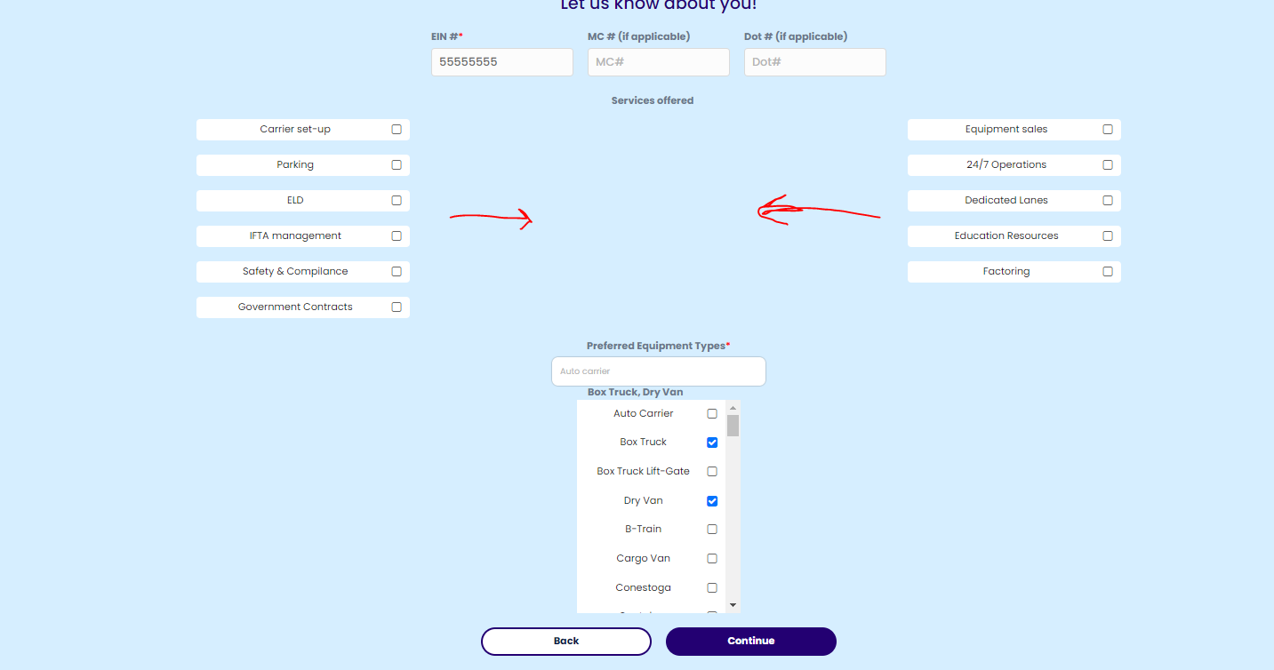

**Payment Processing-** Payment process is good as is just need to make sure

* There is ability to create and use coupon codes
* Both 7-day and 30-day trials should be in place
* If a subscription fee is NOT processed, once the user attempts to login that should see pop up below. They should not be able to click past this screen until a payment is successfully processed.

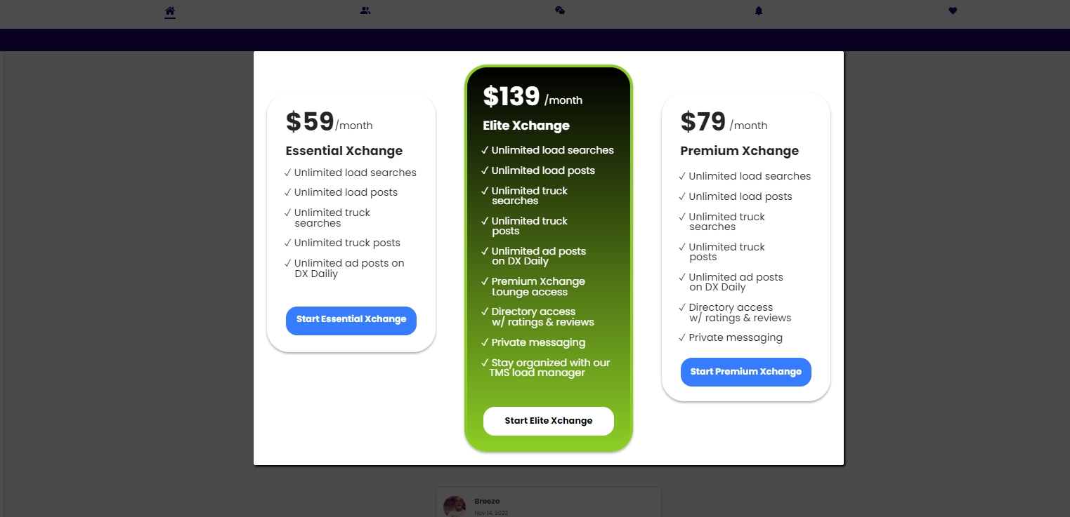

**Welcome email** is attached in drive.

Subject: Welcome to Dispatch Xchange

Body: Document attached in drive

**Home page**

* Social Timeline similar to facebook. (text,gifs,emojis,images,video)
* Ability to like and comment on post
* When you click usernames anywhere on the site it should take you to that users Xchange directory profile.

**Active users-** Shows active users on the platform in real time. If you click on a user, it takes you to the inbox to message them.

**Menu/headings-** The headings and menu are all accurate on the Bubble site.

**Xchange Board (Desktop)** the fields and headings are all correct however, all pages should be formatted neatly with the headings aligned and fully extended across the page w/ no extra space. All post should expand with accurate details and map with route. Example below.



Expanded view options:

User posts it (editable) vs. somebody else posting (View, save, or message only)

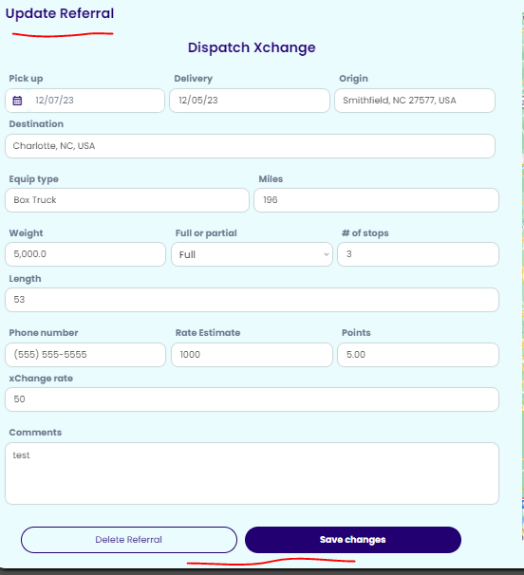 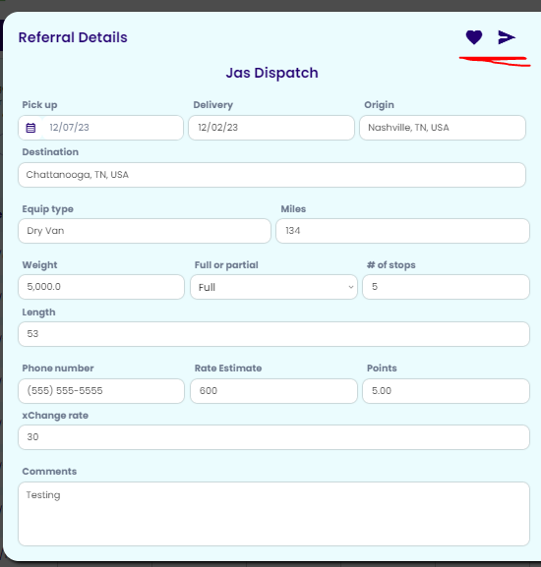

* **Post Load Referrals**

Make sure Disclaimer is present, Xchange rate should auto calculate once rate estimate and points are entered. 1,000 -5% = $50



* **Available Referrals**

Make sure Disclaimer is present

* **Post Trucks**
* **Available Trucks**

**Xchange Board (Mobile)**

The mobile Xchange Board should be formatted the way we discussed initially. Example Pictured below.

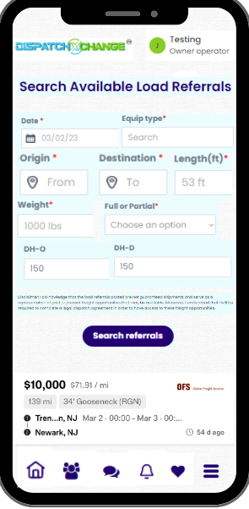 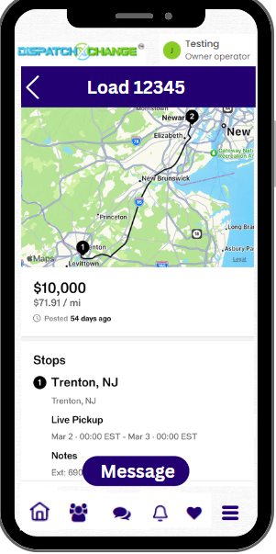 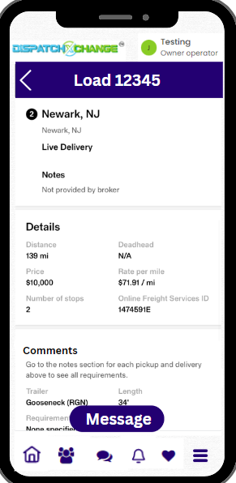

**Load Manager**

The purpose of the load manager is to allow users to manage and organize their day to day transactions. Each user should have their own database that saves their load information and uploaded documents so they can reference them any time.

* Fields with “+” should expand to enter additional info. Once saved the text from the first line should populate in the main field. Example shown below in the Bill to and Driver name fields.
* There needs to be a large text box added at the bottom for “Additional Notes” .
* The search function on the load manager home page should allow users to search all of their loads by date, status, and key words.
* When the load is moved into the completed/Delivered status, it should be moved over to that tab.
* Load numbers are auto generated starting with load 0001 and increase in chronological order.

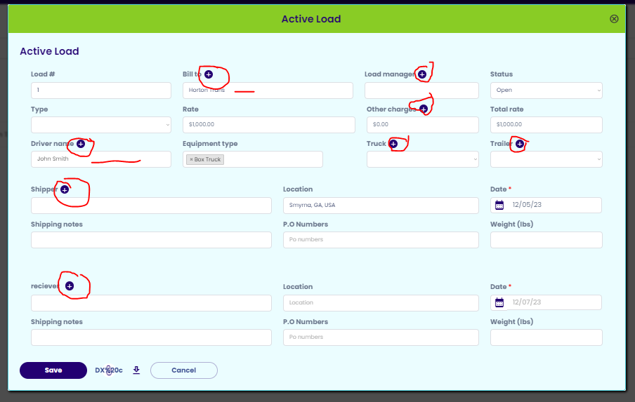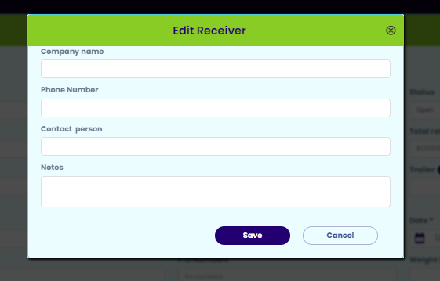

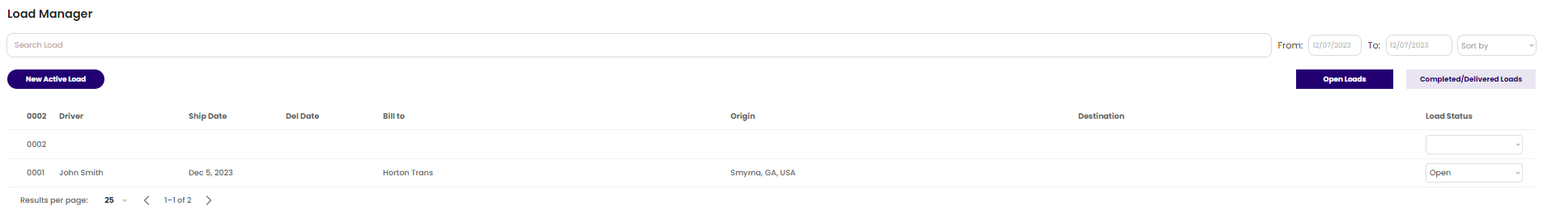

**Xchange Agreements**

* Agreements are attached in drive.
* Agreement descriptions are correct on Bubble site

**Xchange Lounge**

We have discussed this design and I have provided layout

**Xchange Directory**

The design and filters are perfect for this section on the Bubble site.

**Report Misconduct**

This section should be connected to the Admin dashboard. The “Your company name” field should auto populate the username. The “User you are reporting” field should give a list of all users to select from.

* Once a report is submitted the user should get a pop up saying their submission has been sent and they will be contacted shortly.
* Once the report is submitted the form should reset.
* The report should be sent to the misconduct reports section of the admin dashboard.

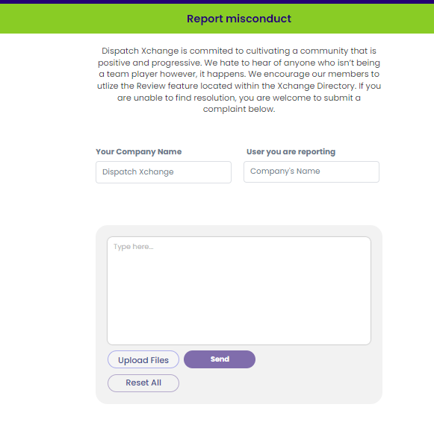 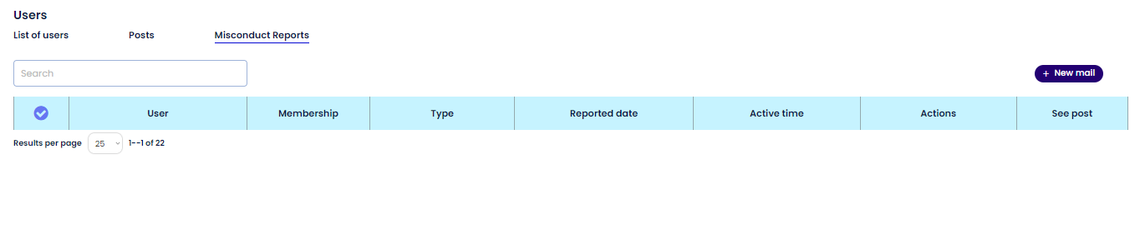

**User Help**

This page is pretty simple and should just allow users to click the email and contact us from there.

**Inbox**

The inbox design on Bubble is not ideal and pretty basic. If you know a better design I’m open to it. Just need it to make sense on the desktop and mobile. I do like that they can select from a list of users when they are starting a new conversation.

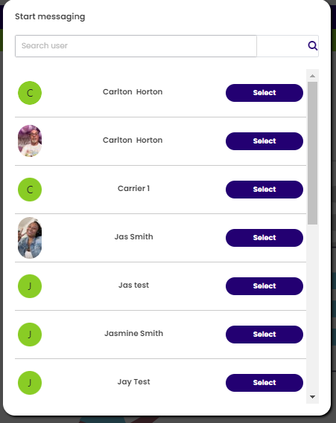

* When users receive a new message they should see a visual notification (pictured) 
* Users should still get notified even If their subscription doesn’t allow them to access the inbox to encourage them to upgrade.
* Once they upgrade their account they should be able to see all of the messages.

**Saved**

This section is good just need to make sure the load and truck posts display and expand the same way they do on the Xchange Board.

**Profile**

All of the fields are good on the bubble site. Just need to make sure registration info carries over. Specifically the MC & DOT if they are provided. If they are not provided they can provide later when they edit their profile. Also make sure they can reset their password and manage their subscription.

**Reviews**

**User should be able to read and leave reviews within the Xchange Directory. Users will manage and reply to their own reviews from their profile section.**

**Admin**

The Admin dashboard in the figma design and the one we currently have differ a little because some of the fields didn’t make sense. What we have in Bubble will work for now. The only thing missing are the charts and graphs that were there initially. Main things are being able to monitor growth, users, posts, misconduct reports, lounges, send mass and individual emails, and create coupons.

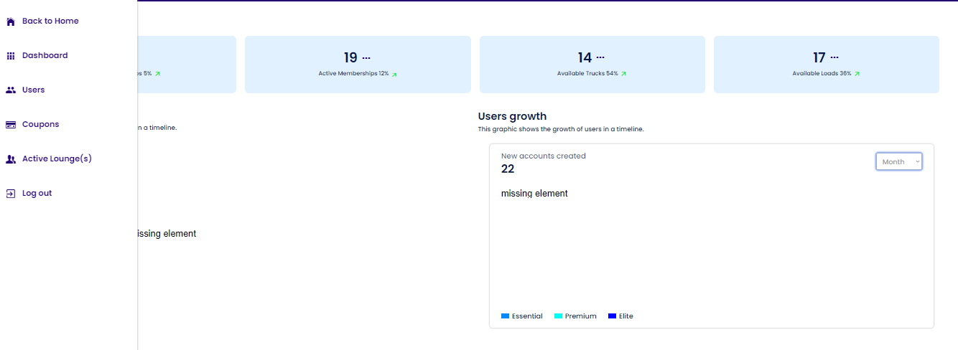

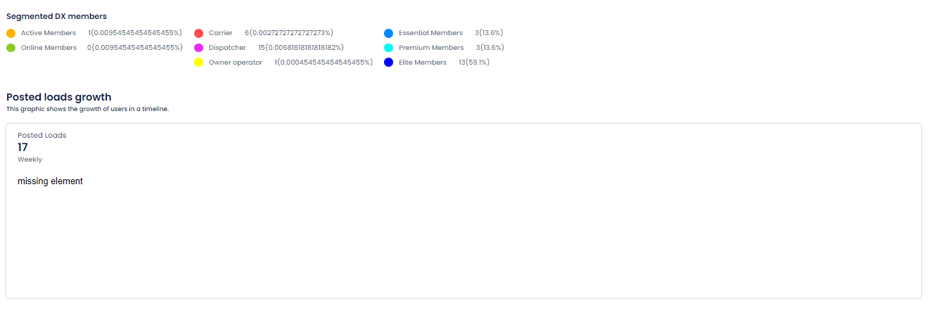

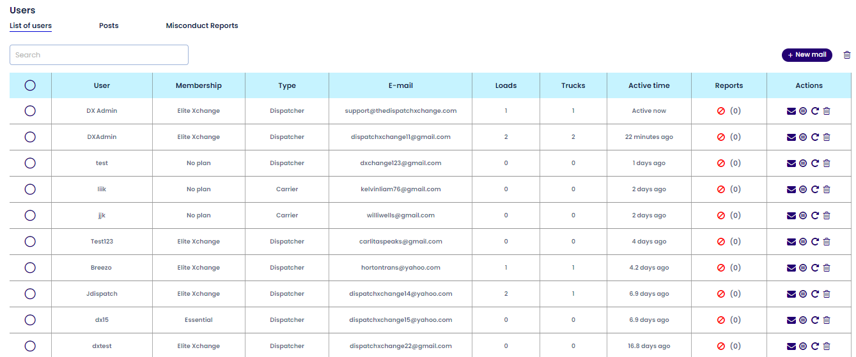

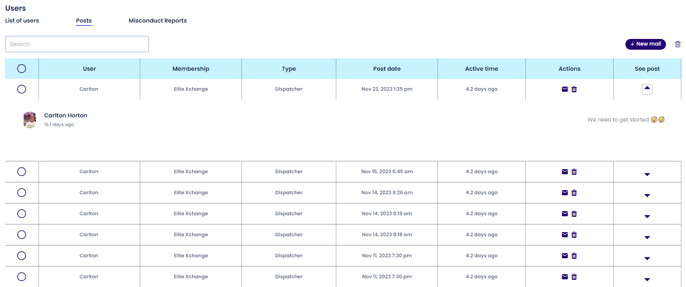

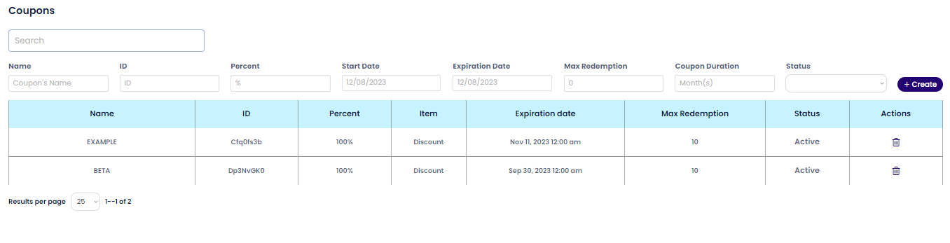

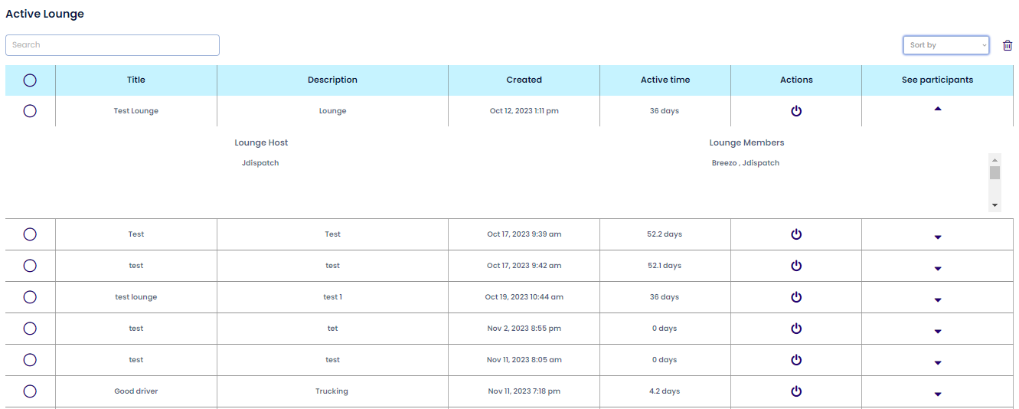

**Subscription Access**

**Every subscription has access to the following**

* **Home page/timeline/active users**
* **Xchange Agreements**
* **Report Misconduct**
* **Profile**
* **Saved**
* **User help**

**$59 Essential**

* **Xchange Board**

**$79 Premium**

* **Xchange Board**
* **Xchange Directory**
* **Inbox**

**$139 Elite**

* **Xchange Board**
* **Xchange Directory**
* **Inbox**
* **Xchange Lounge**
* **Load Manager**

**Notifications**

* **New Comment** 
* **New Like** 
* **New Message** 
* **New Lounge created** 
* **\*Username* invited you to the *Lounge name* lounge** 
* **New review** 
* **\*Username* replied to your review** 
* **\*Username* would like to add you to their directory (accept/reject buttons)** 

**Example of the notifications when they come through**

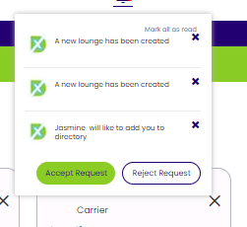

**Logout**

Once a user logs out they should be directed back to the landing page.